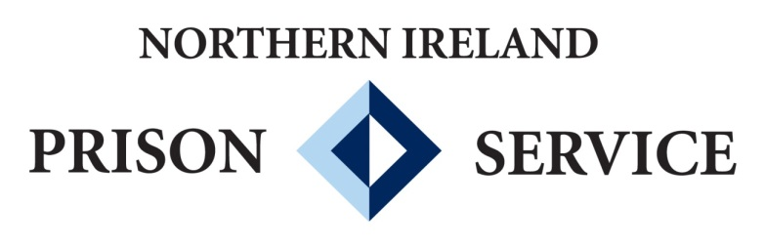

**Creating a Smoke Free Prison**

**Environment**

**Public Consultation**

In its Prisons 2020 year two plan, the Northern Ireland Prison Service (NIPS) laid out its intention for all prisons in Northern Ireland to be smoke free by September 2020.

Our move to smoke free prisons has been informed by the success of the implementation of smoke free prisons in the Scottish Prison Service, Her Majesty’s Prison and Probation Service and the Isle of Mann Prison Service in recent years.

While we have a policy in place that restricts the areas within a prison where people in our care may smoke, thereby reducing the exposure of smoke to others. It is still not acceptable that those in our care and those who work in our prisons should be exposed to second hand smoke.

The fact remains that the only way to remove this risk is to remove smoking from our prisons. This will be a significant challenge as the percentage of people who smoke in prisons is higher than the general community. I fully understand how difficult it will be for many in our care to give up smoking – that is why we are committed to working alongside our partners to provide every support possible to assist them.

Through this consultation we are seeking your views about how we should do this and what things we should take into consideration during the planning and implementation and I look forward to receiving your views on this important issue.

We are all working towards having a Northern Ireland where we enjoy long, healthy and active lives and I believe this is a significant milestone on that journey.

AUSTIN TREACY

Director of Prisons, Northern Ireland Prison Service

**Why are we consulting?**

Consultation is a fundamental part of our policy making process. Moving to smoke free prisons in Northern Ireland will be a significant challenge and we want to hear your views on how we should address some of the challenges we expect to face. This short document sets out the issues we need to look at and asks you questions about what we are proposing.

This is a public consultation and anyone can respond. Over the course of the project NIPS will work with a number of partner agencies to identify the best ways that we can support those in our care in advance of, during and following our move to smoke free prisons. We will also consult with those in our care.

Responses will be analysed and may be used as part of the policy making process, along with a range of other information and evidence. After the consultation is closed, we will publish responses when we have been given permission to do so, along with a short summary of the feedback we have received.

**Responding to the consultation**

The consultation is taking place over a 6 week period and will close on 30 November 2019. The consultation can also be accessed online at [www.justice-ni.gov.uk/consultations](http://www.justice-ni.gov.uk/consultations)

We have provided a “Respondent Information Form” that asks information about you or your organisation. We have also provided a “Response Form” that lists the questions that we would like you answer. It is important that the Respondent Information Form is completed and returned along with your response as this will ensure we handle your response appropriately.

You may answer as many of the questions as you want. You do not need to answer them all. Everything you tell us will help us in our in our planning to move to a smoke free prison environment in Northern Ireland.

We are inviting written responses to this consultation. The consultation closes on 30 November 2019. We are happy to accept your responses on the enclosed form or on a separate piece of paper. You can email your responses to [NIPSSmokeFreePrisons@justice-ni.x.gsi.gov.uk](mailto:NIPSSmokeFreePrisons@justice-ni.x.gsi.gov.uk).

**Response Form**

The Northern Ireland Prison Service (NIPS) wants our prisons to be safe and healthy places for people who live, work and visit them and that is why we have made a public commitment to work towards smoke free prisons. It is our intention for all prisons in Northern Ireland to be smoke free by the end of September 2020. The sale of tobacco products will cease in 2020 and NIPS will use our Prison Rules to make smoking in Northern Ireland’s prisons illegal.

NIPS will be working with partner agencies to develop a wide range of supports and interventions to assist those people in our care to give up smoking.

|  |
| --- |
| 1. **What steps can NIPS take to support people in custody to stop smoking?** |
| Response: |

|  |
| --- |
| 1. **How can we help families to support people in custody to stop smoking?** |
| Response: |

|  |
| --- |
| **3. What range of measures should NIPS aim put in place?** |
| Response: |

|  |
| --- |
| 1. **Who should NIPS be engaging with when planning the move to smoke free prisons and following implementation?** |
| Response: |

|  |
| --- |
| 1. **What other information do you have that would help us deliver the aims of this project?** |
| Response: |
| 1. **What other comments do you have?** |
| Response: |

**Respondent Information Form**

**Please Note** this form **must** be completed and returned with your response.

Are you responding as a Person in Custody, individual or an organisation?

Person in Custody Individual Organisation

Full name or organisation’s name

|  |
| --- |
|  |

Prison or Address (Including post code)

|  |
| --- |
|  |

Email Address

|  |
| --- |
|  |

NIPS would like your permission to publish your consultation response. Please indicate your preference below:

|  |  |  |
| --- | --- | --- |
| Publish response with name | Publish response only (without name) | Do not publish |

|  |
| --- |
| Information for organisations: |
| The option “Publish only (without a name)” is available for individual respondents only. If this option is selected, the organisation name will still be published.  If you chose the option “Do not publish response” your organisation name may still be listed as having responded to the consultation in the analysis report. |