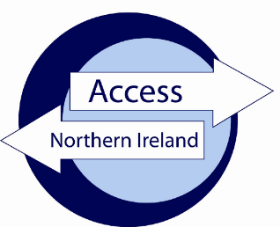

A consultation on proposals to update and reform the AccessNI List of Specified Offences

_____________________________

Response Questionnaire

Responding to our Consultation

We would ask that you respond to the consultation using the online facility on the Citizen Space platform at:

Consultation - List of Specified Offences - Citizen Space

If you are unable to respond using our online consultation facility, you can email your response using this Response Questionnaire to the following email address:

ani@accessni.gov.uk.

You are asked to consider providing the information below*:

Name:

Email address:

I am responding as:

An individual On behalf of an organisation

Name of organisation:

*Details regarding how we will use your personal information are provided in Annex D.
Consultation Questions

P1 Do you agree that the List of Specified Offences as published on the NIDirect website should be renamed ‘List of Non-filterable Offences’?

Yes No

Comment:

P2 Do you agree that s113A(6D) of the Police Act 1997 should be amended in its entirety to read “The offences referred to in paragraphs (a)(i) and (iv) and (c) of the definition of “relevant matter” in subsection (6), as it has effect in Northern Ireland, are the offences on the list of non-filterable offences as maintained and published by the Department of Justice”.

Yes No

Comment:

P3 Do you agree that the wording of Article 1A(4) of the Rehabilitation of Offenders (Exceptions) Order (NI) 1979 should be amended to read “In paragraph 2(a) “listed offence” means an offence on the list of non-filterable offences as maintained and published by the Department of Justice in accordance with s113A(6D) of the Police Act 1997”.

Yes No

Comment:

P4(i) Do you agree that a new committee should be established (The Non-filterable List Committee) to consider future amendments to the List of non-filterable offences?

Yes No

Comment:

P4(ii) Do you agree that a new Non-filterable List Committee should comprise Independent Reviewer of Criminal Record Certificates and representatives from Child Protection Branch (DoH), Protective Disclosure Unit (PSNI) and AccessNI?

Yes No

Comment:

P5 Do you agree that a offences set out in Annex A of the consultation paper should be added to the List of Non-filterable offences?

Yes No

Comment:

P6 Do you agree with the Department’s proposal to amalgamate multiple lines of entries on the List (that relate to the same article / section of and Act or Order) into a single entry on the list, using generic offence descriptors, thereby reducing the size and complexity of the List?

Yes No

Comment:

P7 Do you agree with the Department’s proposal to include the current legislative provision at s113A(6D)(lll) and (mmm) as a list at the bottom of the new List of Non-filterable offences?

Yes No

Comment:

Thank you for participating in this Consultation. Please return this response by email to:-
ani@accessni.gov.uk

Or by post to :-

AccessNI
PO Box 1085
Belfast
BT5 9BD

