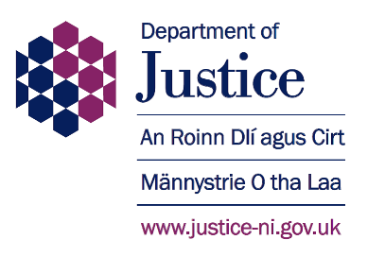

**PROBATION BOARD FOR NORTHERN IRELAND**

**The Department of Justice is seeking to appoint a Chairperson and 12 Board members to the Probation Board for Northern Ireland (PBNI).**

The Probation Board came into existence in 1982 and is a Non-Departmental Public Body sponsored by the Department of Justice; its statutory responsibilities are set out in the Probation Board (NI) Order 1982. Board members are appointed by, and accountable to, the Minister of Justice. The Board can consist of a Chair, a Deputy Chair and between 10 to 18 board members. In this competition the Minister is seeking to appoint a Chair and 12 Board Members. A Deputy Chair will be appointed via an internal process from the pool of board members following appointment.

The successful candidates will bring experience, professionalism and knowledge to these posts.They will have a successful track record built on Leadership, Building & Maintaining Effective Relationships, Governance & Organisational Performance and Strategic Thinking.

The Chairperson and Board Members are appointed for a term of three years. The maximum number of terms that they can serve is two. There is no automatic reappointment to the roles and therefore, should the Chairperson and Board Members wish to serve a second term, they are required to reapply for the role.

The Chairperson will be required to work a minimum of two days a week and remuneration for this position is £33,010.

Board Members attendance is a minimum of 25 days per annum and remuneration for these positions is £5,050 per annum.

Candidate information packs and applications forms are available on the DOJ website at [Recruitment Probation Board Northern Ireland | Department of Justice](https://www.justice-ni.gov.uk/publications/recruitment-probation-board-northern-ireland)

**We particularly welcome applications from women, people under the age of 40, individuals from a minority ethnic community and people with a disability.**

**THE DEADLINE FOR RECEIPT OF APPLICATIONS IS 12 NOON (UK LOCAL TIME) ON MONDAY 16 DECEMBER 2024. LATE APPLICATIONS WILL NOT BE ACCEPTED.**

It is anticipated that interviews will be held on **w/c Monday 20 January 2025 & w/c Monday 3 February 2025.**

Further information and an application pack can be downloaded direct from: [Recruitment Probation Board Northern Ireland | Department of Justice](https://www.justice-ni.gov.uk/publications/recruitment-probation-board-northern-ireland) or by emailing: [pbni.appointments@justice-ni.gov.uk](mailto:pbni.appointments@justice-ni.gov.uk)

or by telephoning: 028 9052 6496

or by writing to: PBNI Competition 2024, Department of Justice, Public Appointments, Room C4, Castle Buildings, Stormont Estate, Belfast, BT4 3SG.

Candidate information packs and application forms can be provided in alternative formats on request.

**Equality of Opportunity**

The Department of Justice is committed to the principles of public appointments based on merit with independent assessment, openness and transparency of process. The Department is committed to providing equality of opportunity for all applicants. Applications are welcomed regardless of age, gender, disability, marital status, religion, ethnic origin, political opinion, sexual orientation or whether or not you have dependants. In keeping with the NICS Policy on Equality, Diversity and Inclusion, we would also welcome applications from those not currently serving on public bodies.

|  |  |
| --- | --- |
|  |  |

